**Physics Report**

**Rationale**

A pendulum is body suspended from a fixed point so that it can swing back and forth under the influence of gravity (Britannica). Pendulums are used in many everyday inventions, some obvious such as the pendulum clock and some less so such as swing sets or seismometers. Pendulums function by utilising the fact that acceleration due to gravity is always downwards and is towards its equilibrium point. This downwards velocity produced by gravity is then converted into horizontal velocity because of the rotation of the object. Assuming no external factors such as friction or air resistance the relationship between the period time, pendulum length and acceleration due to gravity of a pendulum can be found in the following formula (formula). In this formula it can be seen that mass is absent as, acceleration due to gravity is constant for all objects regardless of their mass. This is phenomenon is also found in the experiment of dropping a bowling ball and feather in a vacuum. The initial angle is also missing because although the pendulum experiences higher displacement with higher angles it travels faster as it accelerates for a longer time. These two effects cancel each other out causing the period of the pendulum to remain the same regardless of the initial angle.

**Research Question**

Does changes to mass not affect period of a pendulum while pendulum length and acceleration due to gravity remain constant?

**Method Modifications**

In the original method a ball is dropped at various heights and the time it takes to impact the ground is measured with a stopwatch. In the modified experiment used for this report, instead a pendulum is dropped at a constant angle and the time it takes for five periods to occur is measured. This is repeated with increasing amounts of weight on the pendulum to find a relationship between weight and the period time. Five trials of five periods were used instead of three trials in the previous experiment. This is because it significantly increases the amount of sample of data to give a more precise result. The pendulum was used because it is easier to drop consistently and time as the person using the stopwatch can more accurately anticipate when the pendulum will stop.

**Safety**

|  |  |  |
| --- | --- | --- |
| Hazard | Injury | Control + Management |
| Falling Masses | Bruised foot | Keeping masses together and avoiding knocking them of the table |
| Pendulum Detaching from string | Blunt Trauma | Verifying the knot used by pulling on it before use |
| Retort stand falling over | Blunt Trauma | Putting heavy books on the base of the stand to stop it from wobbling |

**Results**

|  |  |  |  |  |  |  |
| --- | --- | --- | --- | --- | --- | --- |
| Weight | Trial 1 | Trial 2 | Trial 3 | Trial 4 | Trial 5 | Average |
| 0.1 | 5.22 | 5.4 | 5.25 | 5.19 | 5.41 | 5.294 |
| 0.2 | 5.16 | 5.22 | 5.34 | 5.16 | 5.31 | 5.238 |
| 0.3 | 5.13 | 5.18 | 5.34 | 5.13 | 5.28 | 5.212 |
| 0.4 | 5.22 | 5.06 | 5.47 | 5.09 | 5.12 | 5.192 |
| 0.5 | 4.94 | 5.28 | 5.16 | 5.21 | 5.12 | 5.142 |

|  |  |  |  |  |  |  |
| --- | --- | --- | --- | --- | --- | --- |
| Trial 1 Average Period | Trial 2 Average Period | Trial 3 Average Period | Trial 4 Average Period | Trial 5 Average Period | Average Period | Absolute Uncertainty |
| 1.044 | 1.08 | 1.05 | 1.038 | 1.082 | 1.0588 | 0.022 |
| 1.032 | 1.044 | 1.068 | 1.032 | 1.062 | 1.0476 | 0.018 |
| 1.026 | 1.036 | 1.068 | 1.026 | 1.056 | 1.0424 | 0.021 |
| 1.044 | 1.012 | 1.094 | 1.018 | 1.024 | 1.0384 | 0.041 |
| 0.988 | 1.056 | 1.032 | 1.042 | 1.024 | 1.0284 | 0.034 |

Calculating Average Period in trial

Calculating Average Period across trials

Calculating Absolute Uncertainty

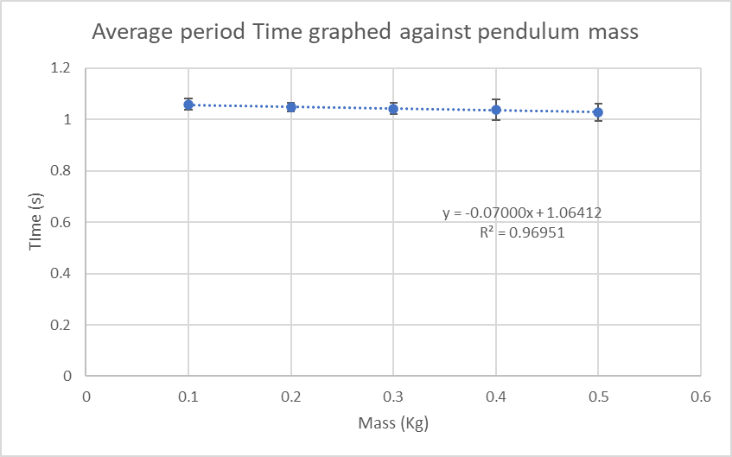

**Analysis & Interpretation**

As seen in figure one there is very slight decrease in period time as more mass is added to the pendulum. The amount of uncertainty also trended upwards simultaneously.

**Evaluation**

**Improvements and extensions**

**Conclusion**

**References**

https://www.britannica.com/technology/pendulum

Notes:

Flow of text

Rationale:

Start broad, go narrow

Physics theory (formula)

Method:

Brief explain OG expirment.

Ethics

Environmental

Animal

People

Waste

Data

Raw data table mean and uncertainty

Sample calc

Evaluation

Improvements

References

Use 3

Materials

* Retort Stand
* Ruler
* Protractor
* String
* Stopwatch
* Slotted Masses
* Slotted Mass stand

1. Attach string and protractor to retort stand
2. Attach string to retort stand ensuring the sitance between the top of the string and the bottom of the stand is 0.3 m